**Mobile automation using – Selendroid**

# **Required/Used components**

* Eclipse
* Java EE IDE for Web Developers.
* Version: Kepler Service Release 2
* [Java 1.8](http://www.oracle.com/technetwork/java/javase/downloads/jdk8-downloads-2133151.html) (Complied with JRE1.7+)
* [Android Studio SDK & AVD](https://developer.android.com/sdk/index.html#win-bundle)
* Environment Variables
* JAVA_HOME = C:\Program Files\Java\jdk1.8.0_25
* ANDROID_HOME = C:\Users\ashishba\AppData\Local\Android\sdk
* Path =%ANDROID_HOME%\platform-tools;%ANDROID_HOME%\tools;%ANDROID_HOME%\platforms;
* Reference Libraries
* selenium-java-2.45.0.jar
* selendroid-standalone-0.15.0-with-dependencies.jar
* selendroid-client-0.15.0.jar
* testng-6.8.jar (Junit or any other framework can be used here)
* AUT
* selendroid-test-app-0.15.0.apk (This should be the APK file of AUT)

# **Reference**

* <http://selendroid.io/>

# **Start Selendroid Server**

## **Command line**

java -jar selendroid-standalone-0.15.0-with-dependencies.jar -app selendroid-test-app-0.15.0.apk

## **OR**

## **Eclipse Java Code**

**private** WebDriver driver = **null**;

**private** **static** SelendroidLauncher *selendroidServer* = **null**;

**if** (*selendroidServer* != **null**) {

*selendroidServer*.stopSelendroid();

}

SelendroidConfiguration config = **new** SelendroidConfiguration();

config.addSupportedApp("lib/selendroid-test-app-0.15.0.apk");

*selendroidServer* = **new** SelendroidLauncher(config);

*selendroidServer*.launchSelendroid();

driver = **new** SelendroidDriver(**new** SelendroidCapabilities("io.selendroid.testapp:0.15.0"));

**Note:** Checkout this program at [Github](https://github.com/ashishbaraiya/MobileAutomation/blob/master/Selendroid/src/com/mobileauto/test/UserRegistrationTest.java) for more detail.

# **Reference Libraries (JARS)**

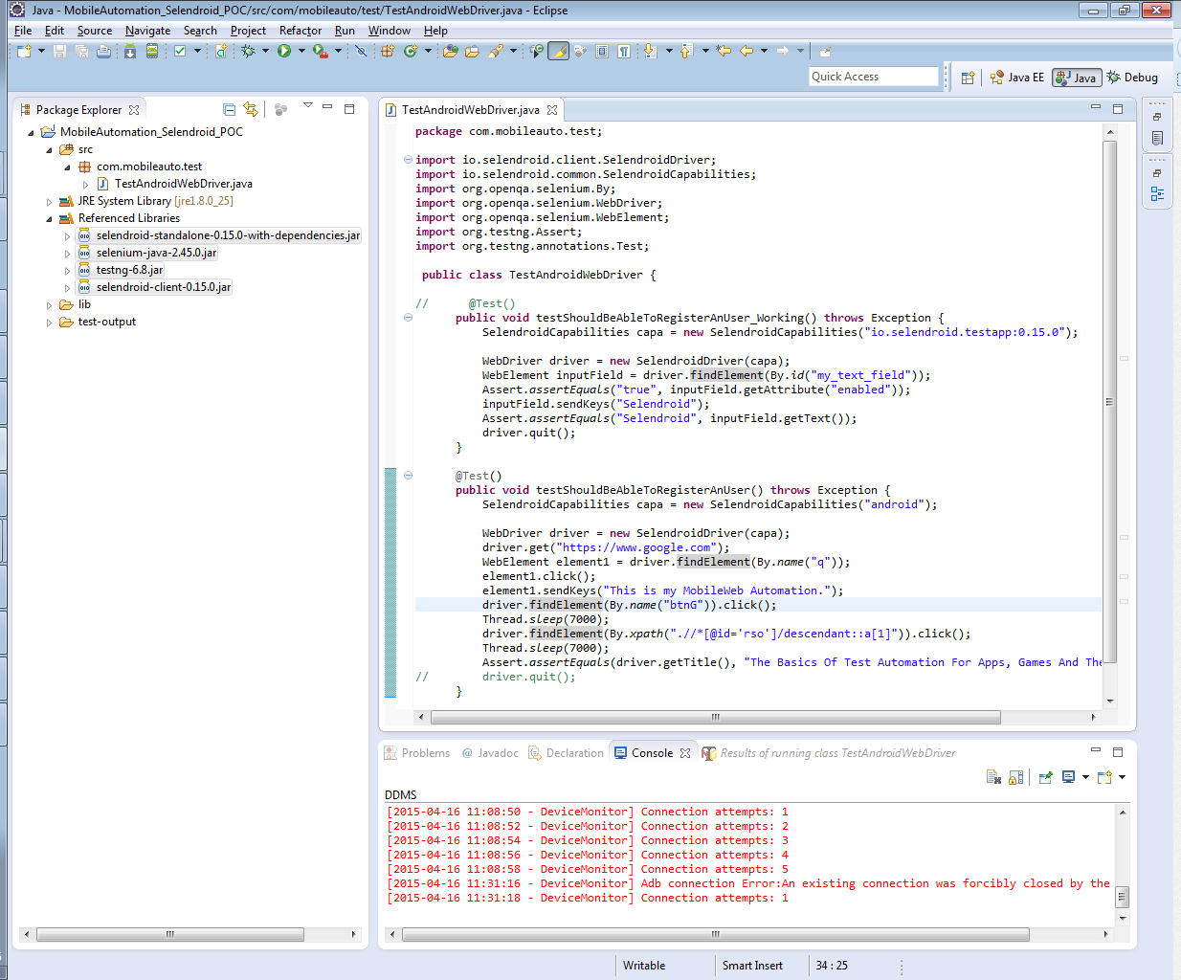

# **Sample program**

@Test()

**public** **void** APKTest() **throws** Exception {

SelendroidCapabilities capa = **new** SelendroidCapabilities("io.selendroid.testapp:0.15.0");

WebDriver driver = **new** SelendroidDriver(capa);

WebElement inputField = driver.findElement(By.*id*("my_text_field"));

Assert.*assertEquals*("true", inputField.getAttribute("enabled"));

inputField.sendKeys("Selendroid");

Assert.*assertEquals*("Selendroid", inputField.getText());

driver.quit();

}

@Test()

**public** **void** MobileWeb() **throws** Exception {

SelendroidCapabilities capa = **new** SelendroidCapabilities("android");

WebDriver driver = **new** SelendroidDriver(capa);

// WebDriver driver = new FirefoxDriver();

driver.get("https://www.google.com");

WebElement element1 = driver.findElement(By.*name*("q"));

element1.click();

element1.sendKeys("This is my MobileWeb Automation.");

driver.findElement(By.*name*("btnG")).click();

Thread.*sleep*(7000);

driver.findElement(By.*xpath*(".//*[@id='rso']/descendant::a[1]")).click();

Thread.*sleep*(7000);

Assert.*assertEquals*(driver.getTitle(), "The Basics Of Test Automation For Apps, Games, Mobile Web");

driver.quit();

}